Email at least a paragraph describing what you propose to do in your project.  Be sure to include **(a)** a description of the topic from our course that you'll be exploring in your project, **(b)** a specification of how you'd like to show off your understanding, e.g., by paper, video, powerpoint, board-game, poster, etc...  and **(c)** whether you'll be working alone or with someone else, and in particular if you'd like me to help you find someone else to work with.  If you've already determined who you want to work with, you can turn in this homework together if you want.

I encourage you to be as specific as you can in this early proposal, as the more information you give me about what you'd like to do, the more useful feedback I'll be able to give you about good ways to pursue this.

I would like to explore the problem of evil with Scott Collins as my partner. We are going to show off our understanding of the problem of evil through Prezi (<http://prezi.com/>) , which is a more aesthetically pleasing version of Powerpoint.

Here is a rough example of what a Prezi is if you’re unfamiliar:

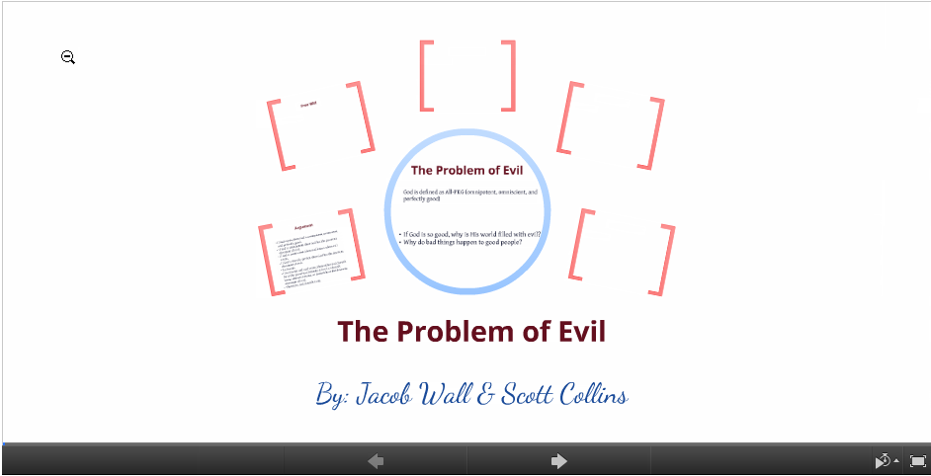

# Outline

* **Main Slide**
  + Overview of slides through Prezi
* **Slide 1 - What is The Problem of Evil?**
  + The problem of evil is an argument that an All-PKG God would not allow suffering or evil.
  + Would God allow evil in order to show us the good?
    - There is evidence against this because God allows unnecessary evil that we do not learn from, such as natural disasters or senseless genocide.
* **Slide 2 – Arguments *against* The Problem of Evil**
  + Unknown Purpose Defense
    - God, as defined, may allow what we consider unnecessary evil for a reason we’re not able to comprehend.
  + Free Will Defense
    - God allows us to have free will and the cause of evil is not but a consequence of us having free will.
    - Abuse of free will outweighs the value of free will and the good that comes of it, and so God is justified in creating a world which offers free will existence, and with it the potential for evil, over a world with neither free beings nor evil.
  + Soul-making Theodicy
    - The theory states that God allows evil since it provides good character building for the victims or in others and that outweighs the negative that evil has.
* **Slide 3 – Objects to each theory**
  + Unknown Purpose Defense
    - If we do not know the purpose then why would an All-PKG God do it? There is no justifiable reason.
  + Free Will Defense & Soul-making Theodicy
    - If this is to be true, then all unnecessary evil is still unjustified
* Slide 4 –
* Slide 5 –
* Slide 6 –